HOME MADE ONE

DFD

AJITH SADANANDAN

MCA S4

Roll no :03

ICET

**LEVEL 0**

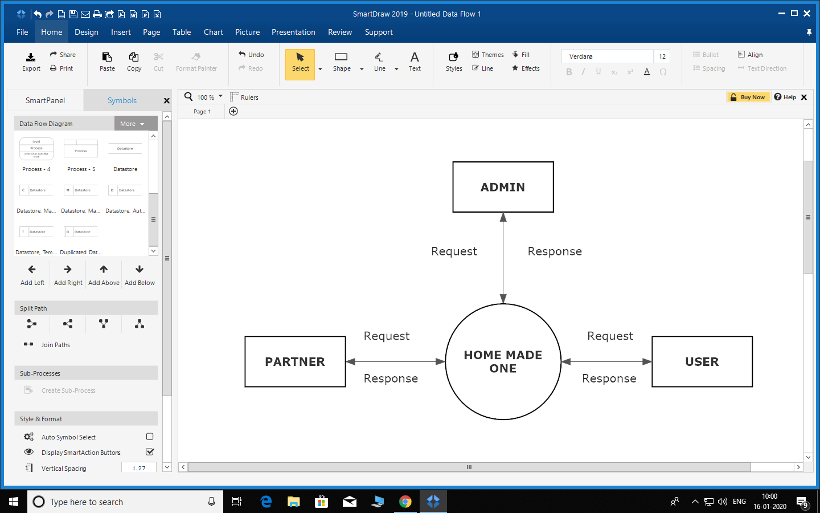

**LEVEL 1 USER**

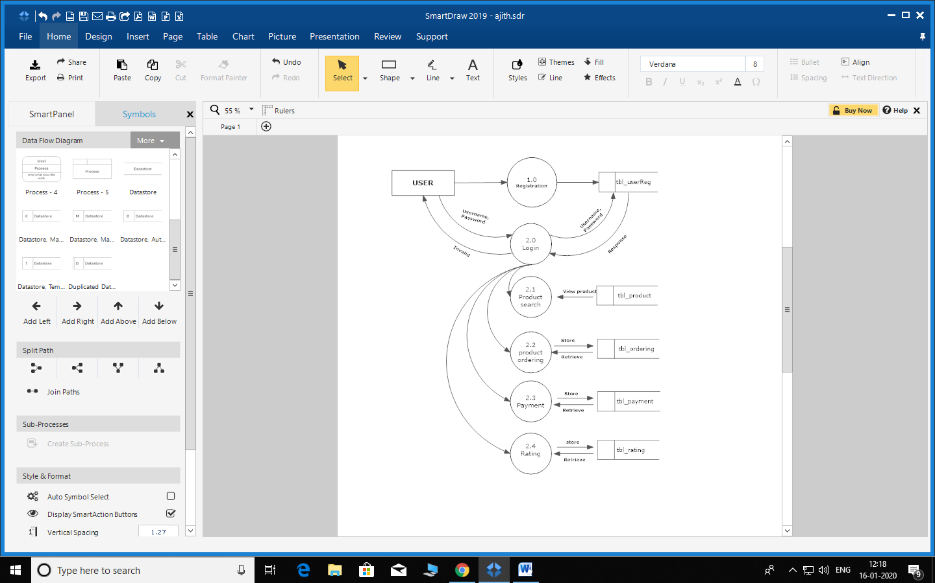

**LEVEL 1 PARTNER**

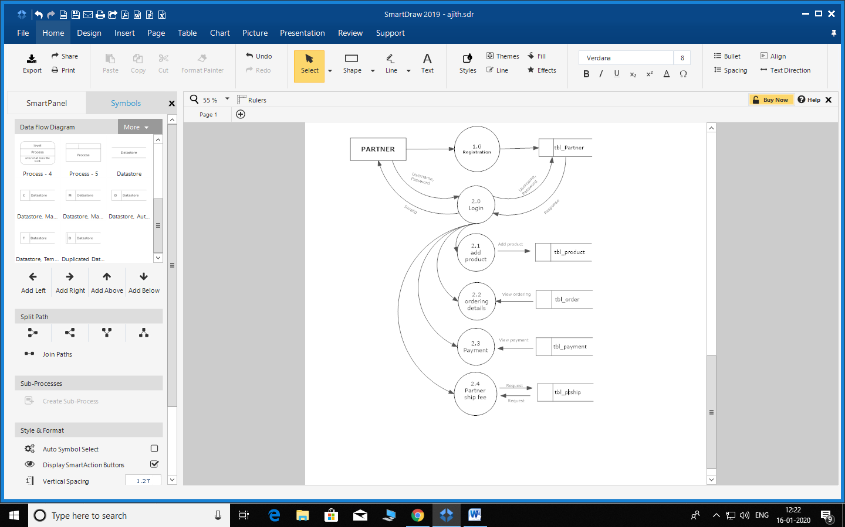

**LEVEL 1 ADMIN**

